Router configuration

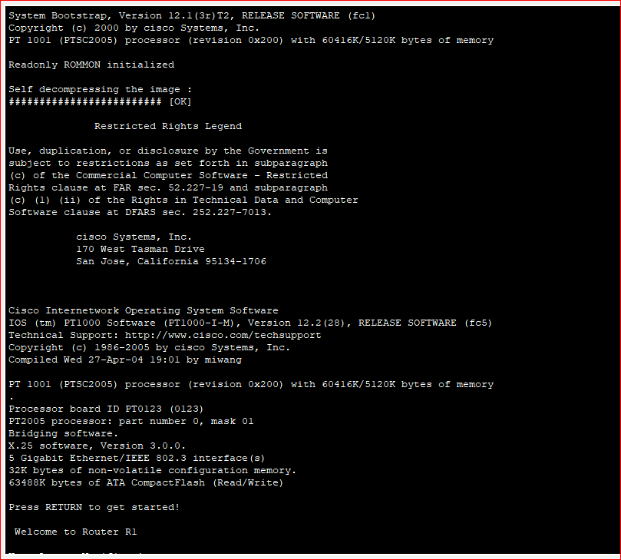

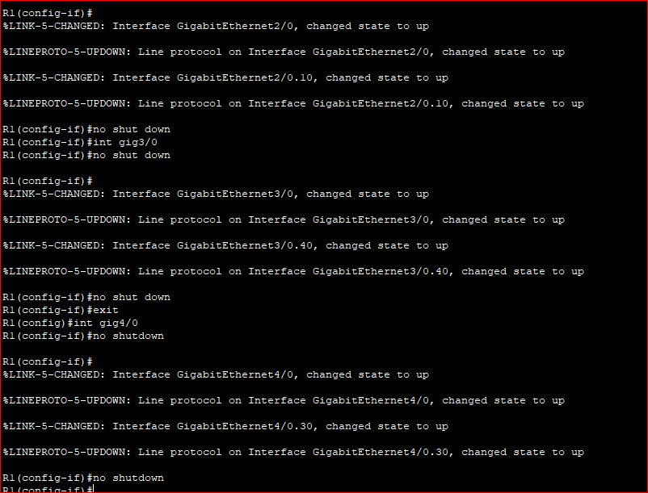

Pc1 ping with router

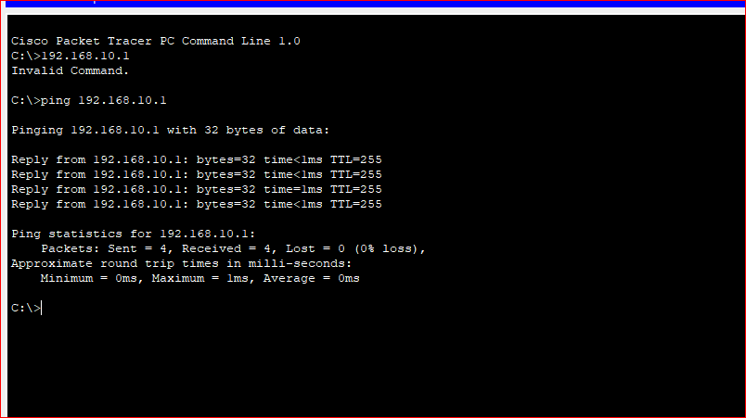

Pc2 ping with router

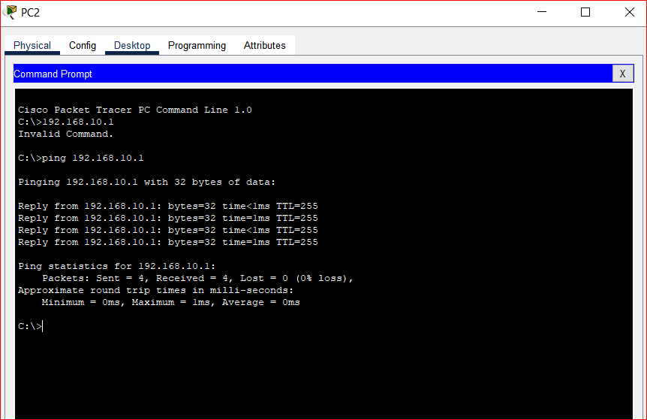

Pc3 ping with router

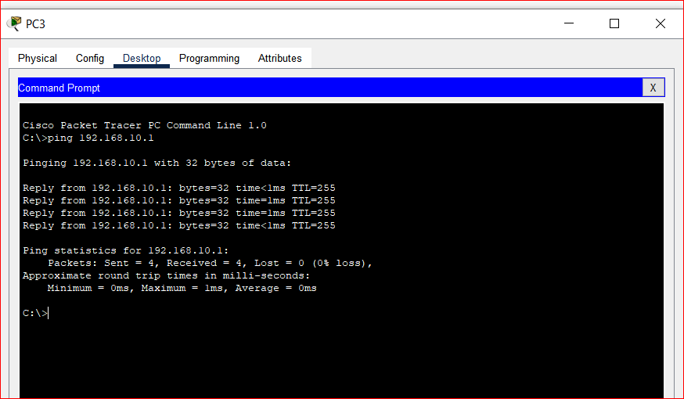

Pc1 ping with DNS server

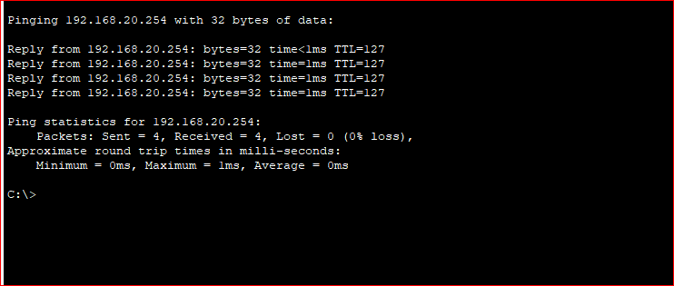

Pc1 ping with web server

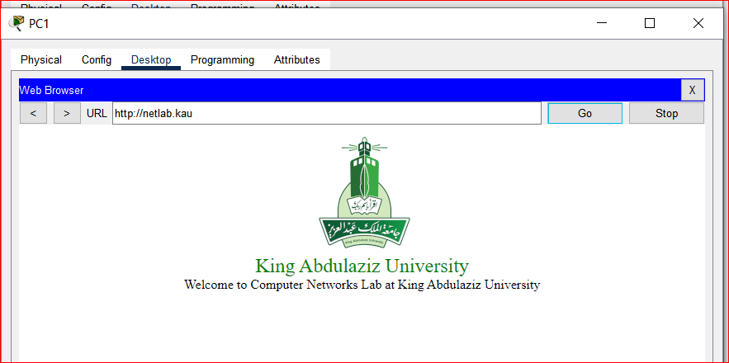

For pc 3

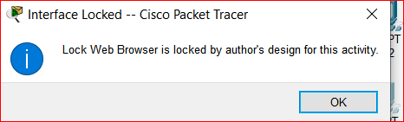

Grade

